**Project Initialization and Planning Phase**

| Date | 05 July 2024 |
| --- | --- |
| Team ID | 739915 |
| Project Name | BlueBerry Yield Prediction |
| Maximum Marks | 3 Marks |

**Define Problem Statements (Problem Statement Template):**

The most challenging task in the agricultural sector is accurately predicting crop yield. Blueberries are a significant agricultural product, and accurate yield prediction is crucial for farmers, suppliers, and retailers to optimize resources, manage supply chains, and ensure market stability. Crop yield depends on various factors such as rainfall, temperature, seeds, and pollination factors. Generally, farmers have higher expectations for the yield they get. To help predict the yield at the end of the season, we can create an efficient, user-friendly experience that aligns with the needs of farmers and retailers. This tool will help them make informed decisions about harvesting and marketing their berries, as well as plan for future seasons.

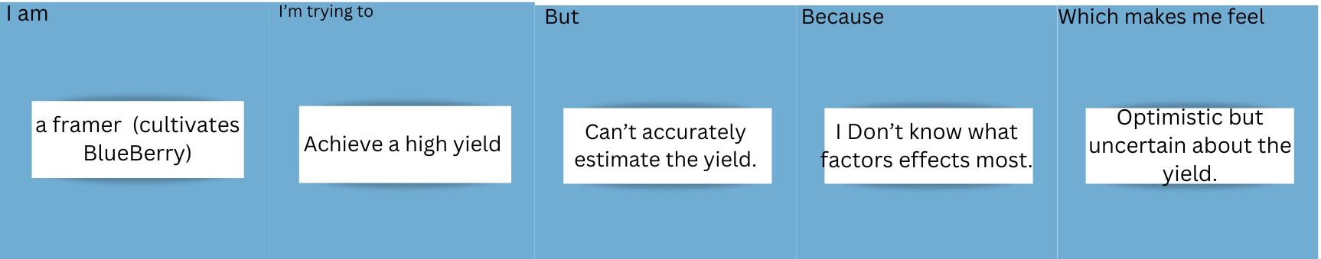

|  |  |  |  |  |  |
| --- | --- | --- | --- | --- | --- |
| **Problem**  **Statement (PS)** | **I am**  **(Customer)** | **I’m trying to** | **But** | **Because** | **Which makes me feel** |
| PS-1 | A Farmer who cultivates Blueberry. | Achieve a high yield | Can’t accurately estimate the yield. | I Don’t know what factors effects most. | Optimistic but uncertain about the yield. |
| PS - 2 | A retails who buys and sales the blueberries | Gain High income in this season | Can’t accurately estimate the yield. | I Don’t know what factors effects most. | Optimistic but uncertain about the yield. |